# **Beagle Bone Black (BBB) Field Guide**

# ***Beagle Bone Black Pin-out Diagram***

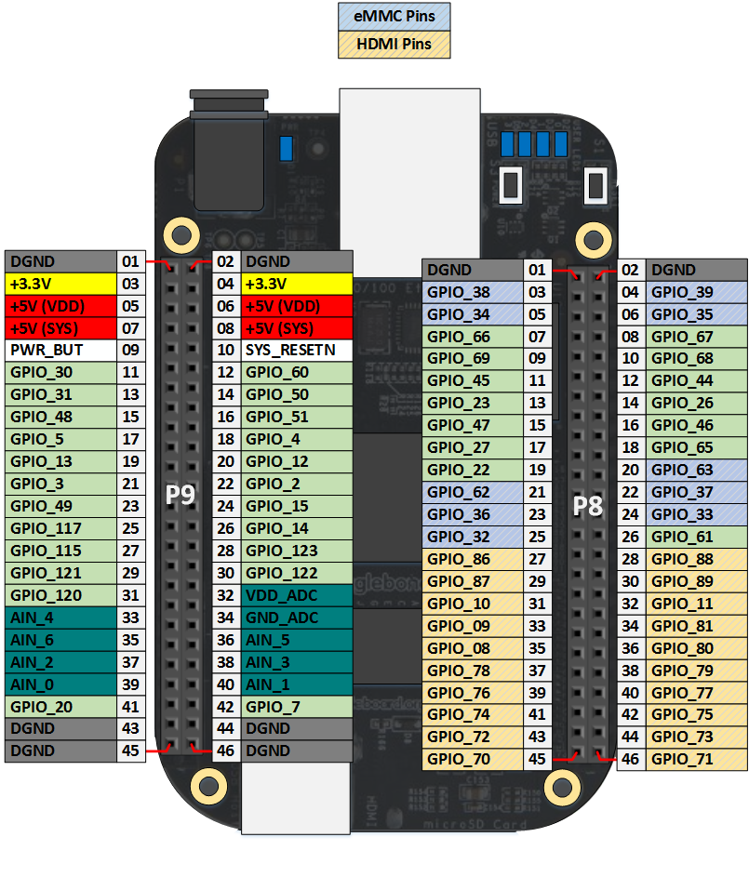

***Product Specifications***

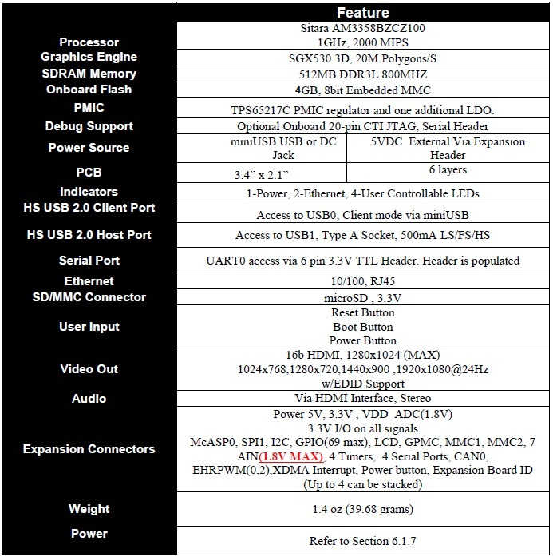

***Power Consumption: (mA when powered at 5V)***

|  |  |  |  |
| --- | --- | --- | --- |
| Mode | USB | DC | DC+USB |
| Reset | TBD | TBD | TBD |
| Idling @Uboot | 210 | 210 | 210 |
| Kernal Booting(Peak) | 460 | 460 | 460 |
| Kernal Idling | 350 | 350 | 350 |
| Kernal Idling Display Blank | 280 | 280 | 280 |
| Loading a Webpage | 430 | 430 | 430 |

***Connectors and Switches***

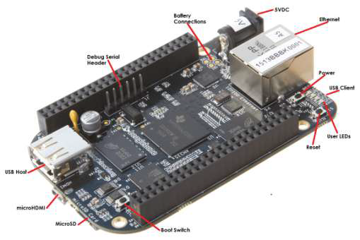

* **DC Power** is the main DC input that accepts 5V power.
* **Power Button** alerts the processor to initiate the power down sequence.
* **10/100 Ethernet** is the connection to the LAN.
* **Serial Debug** is the serial debug port.
* **USB Client** is a miniUSB connection to a PC that can also power the board.
* **BOOT switch** can be used to force a boot from the SD card. There are four blue LED’s that can be used by the user.
* **Reset Button** allows the user to reset the processor.
* **uSD** slot is where a uSD card can be installed.
* **microHDMI** connector is where the display is connected to.
* **USB Host** can be connected different USB interfaces such as Wi-Fi, BT,

Keyboard, etc.

***LED’s***

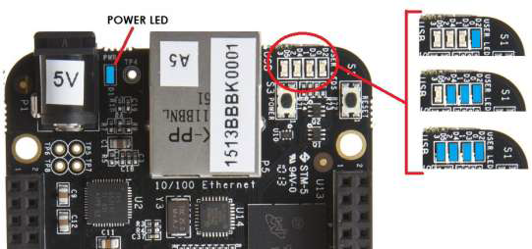

* **USER0** is the heartbeat indicator from the Linux kernel.
* **USER1** turns on when the SD card is being accessed
* **USER2** is an activity indicator. It turns on when the kernel is not in the idle loop.
* **USER3** turns on when the onboard eMMC is being accessed.

***Boot Modes***

* **eMMC Boot…**This is the default boot mode and will allow for the fastest boot

time and will enable the board to boot out of the box using the pre-flashed OS

image without having to purchase an SD card or an SD card writer.

* **SD Boot…**This mode will boot from the uSD slot. This mode can be used to

override what is on the eMMC device and can be used to program the eMMC

when used in the manufacturing process or for field updates.

* **Serial Boot…**This mode will use the serial port to allow downloading of the

software direct. A separate USB to serial cable is required to use this port.

* **USB Boot…**This mode supports booting over the USB port.

**Software to support USB and serial boot modes is not provided by beagleboard.org.**

*A switch is provided to allow switching between the modes:*

* Holding the boot switch down during boot without a SD card inserted will

force the boot source to be the USB port and if nothing is detected on the USB

client port, it will go to the serial port for download.

* Without holding the switch, the board will boot from eMMC. If it is empty,

then it will try booting from the uSD slot, followed by the serial port, and then

the USB port.

* If you hold the boot switch down during boot, and you have a uSD card

inserted with a bootable image, the board will boot form the uSD card.

***Power Button***

A power button is provided near the reset button close to the Ethernet connector. This button takes advantage of the input to the PMIC for power down features. While a lot of capes have a button, it was decided to add this feature to the board to insure everyone had access to some new features. These features include:

* Interrupt is sent to the processor to facilitate an orderly shutdown to save files and to un-mount drives.
* Provides ability to let processor put board into a sleep mode to save power.
* Can alert processor to wake up from sleep mode and restore state before sleep was entered.
* Allows board to enter the sleep mode, preserving the RTC clock

If you hold the button down longer than 8 seconds, the board will power off if you release the button when the power LED turns off. If you continue to hold it, the board will power back up completing a power cycle.

**Sensor Pin-Outs**

**Pin-Outs for Thermocouples**

All thermocouples share the same source for 5V, Ground, CLK(clock), and DO(data out). Each has a separate pin for CS(Chip Select). The chip select pin allows the beaglebone to determine what data is coming from which sensor.

**Shared Pins →** Vin = P9_2, GND = P9_1, CLK = P9_12, DO = P9_23

**CS Pins →** Thermocouple 1: P9_11, Thermocouple 2: P9_13, Thermocouple 3: P9_15

**Pin-Outs for IMU**

|  |  |  |  |  |  |
| --- | --- | --- | --- | --- | --- |
| UART | RX | TX | CTS | RTS | Device |
| 'UART1' | P9_26 | P9_24 | P9_20 | P9_19 | /dev/tty01 |
| 'UART2' | P9_22 | P9_21 |  |  | /dev/tty02 |
| 'UART3 |  | P9_42 | P8_36 | P8_34 | /dev/tty03 |
| 'UART4' | P9_11 | P9_13 | P8_35 | P8_33 | /dev/tty04 |
| 'UART5' | P8_38 | P8_37 | P8_31 | P8_32 | /dev/tty05 |

# ***Troubleshooting Guide***

* **BBB doesn’t turn on (LEDs do not flash when powered):** There may be a problem with the voltage regulation PCB or with the BBB 5V barrel jack. First try disconnecting and reconnecting power for the board. If this fails, try using an alternate 5V power supply to power the BBB through the barrel jack. If failure persists, check to see if the board can be powered though a separate port on the BBB such as though the mini USB connection. If none of these solutions fixes the problem, the BBB is most likely dead. A factory reset may be in order.
* **Sensors not working properly:** First make sure that none of the sensors are tangled, stressed, or mounted incorrectly. If problem persists after checking this, another source of error may result if there are any loose BBB pin connections. Make sure to move the BBB pin connections to other acceptable pins on the BBB one by one to ensure sure that a pin has not been damaged. If this fixes the problem, then make sure to change any code that uses that particular pin to reflect the alteration. If none of these solutions fixes the problem, then the sensor may be damaged and will need to be replaced.